**SACRED HEART GIRLS’ COLLEGE**

**OAKLEIGH**



**Mathematical Methods CAS 2014**

**Unit 3 SAC 1: TEST**

**Part B**

**Name: ________________________________**

**Teacher (please circle)**: Ms Gates Mr Smith Ms Garkel

**Part B: 10 multiple choice questions and 2 extended response questions.**

**CAS and a bound reference of summary notes permitted**

**Writing Time: 40 minutes**

**Marks: 25**

**MULTIPLE CHOICE**

**Instructions:**

Answer **all** questions in pencil on the answer sheet provided for multiple-choice questions.

Choose the response that is **correct** for that question.

A correct answer scores 1, an incorrect answer scores 0.

Marks will **not** be deducted for incorrect answers.

No marks will be given if more than one answer is completed for any question.

**Only the answers on the Answer Sheet will be marked.**

**Question 1**

The maximum domain for the function is

**Question 2**

Which of the following does **not** have an inverse function?

**Question 3**

The simultaneous linear equations

where is a real constant, have infinitely many solutions for

**Question 4**

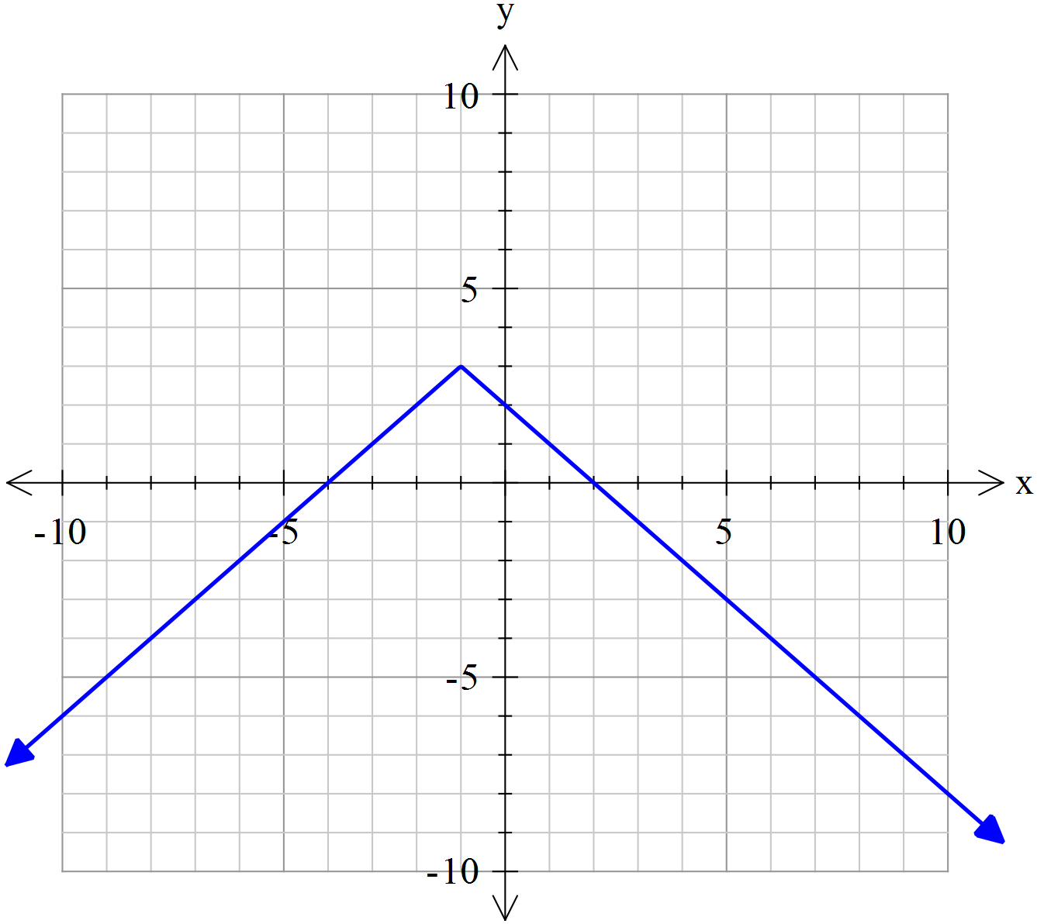

The graph above is best represented by the equation

**Question 5**

Let . Which of the following is **not** true?

**Question 6**

The linear function has range . The domain is

**Question 7**

The graph below shows the function .

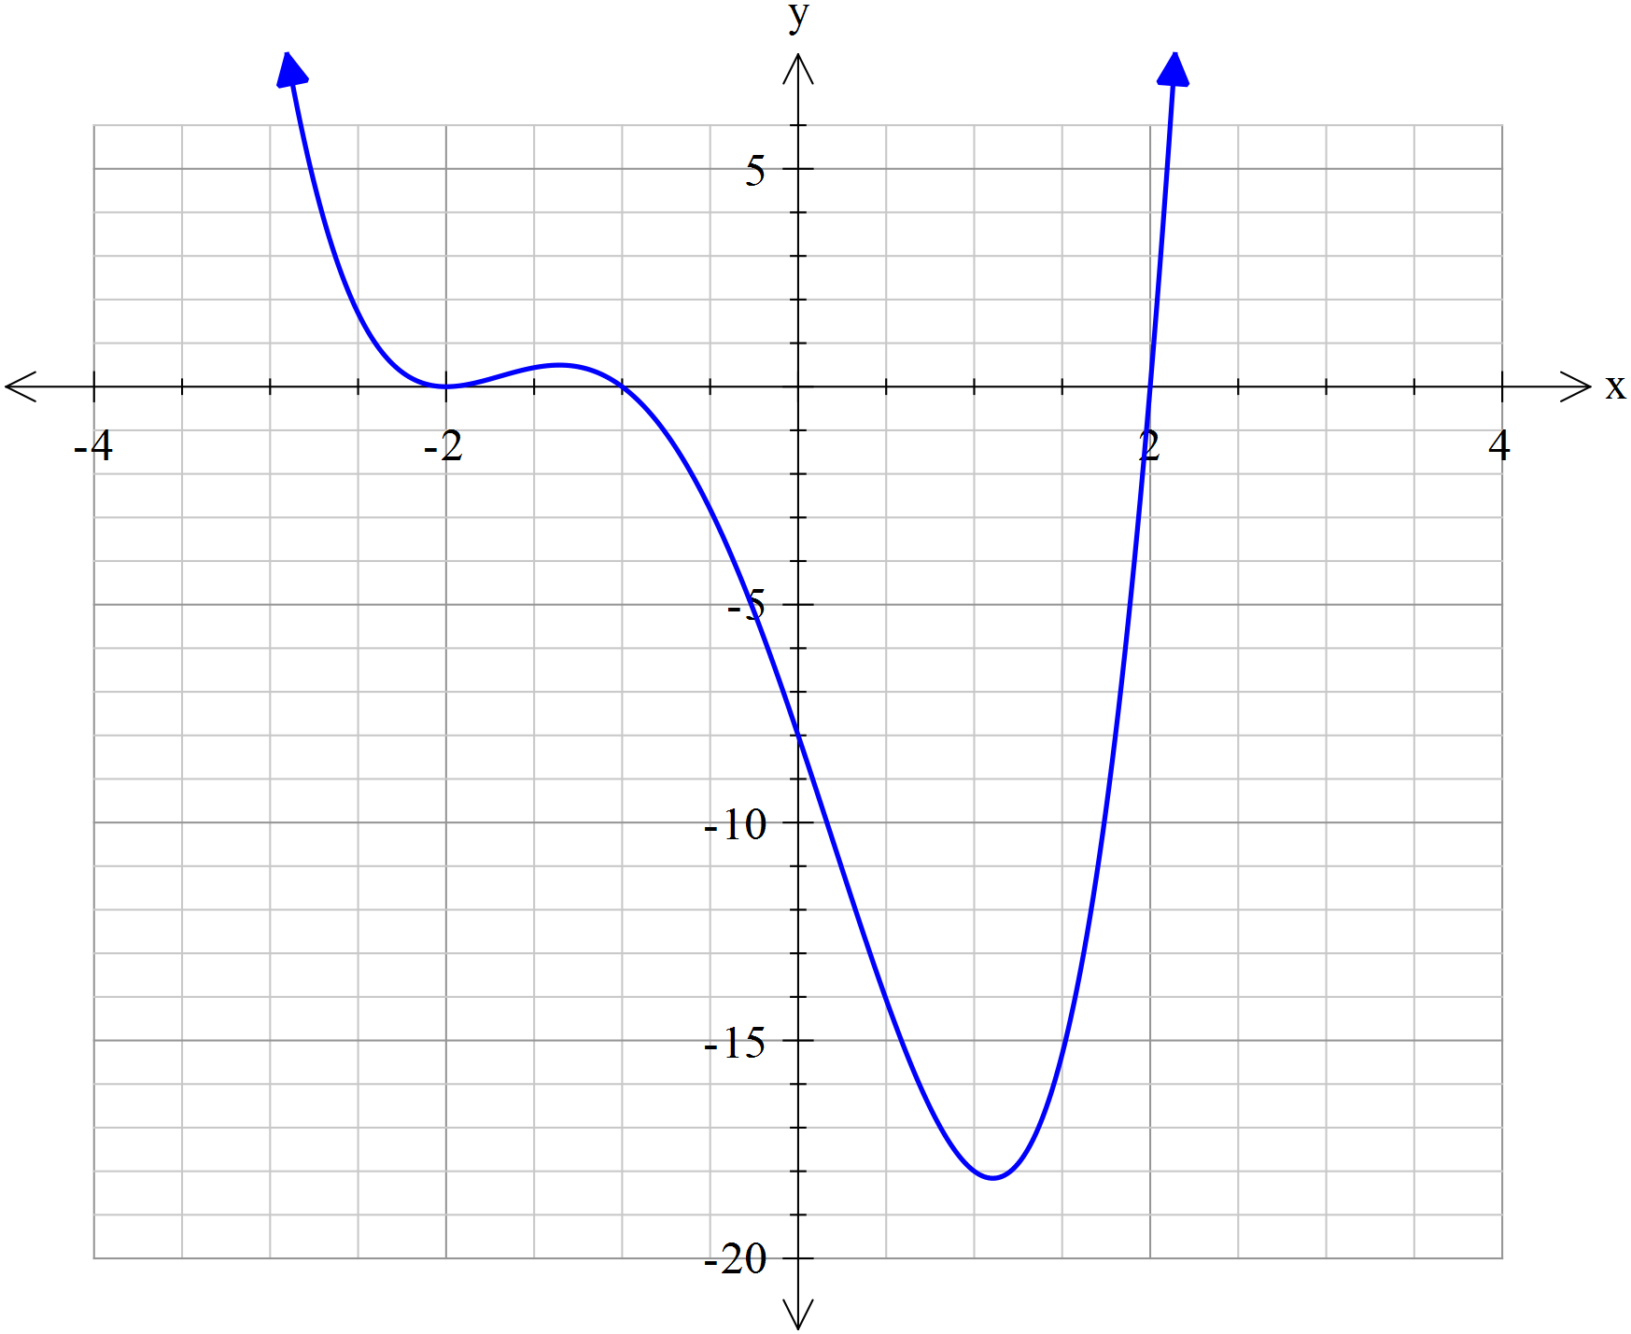

Which of the following is the graph of ?

|  |  |  |
| --- | --- | --- |
|  |  | **C.** |
| **D.** | **E.** |  |

**Question 8**

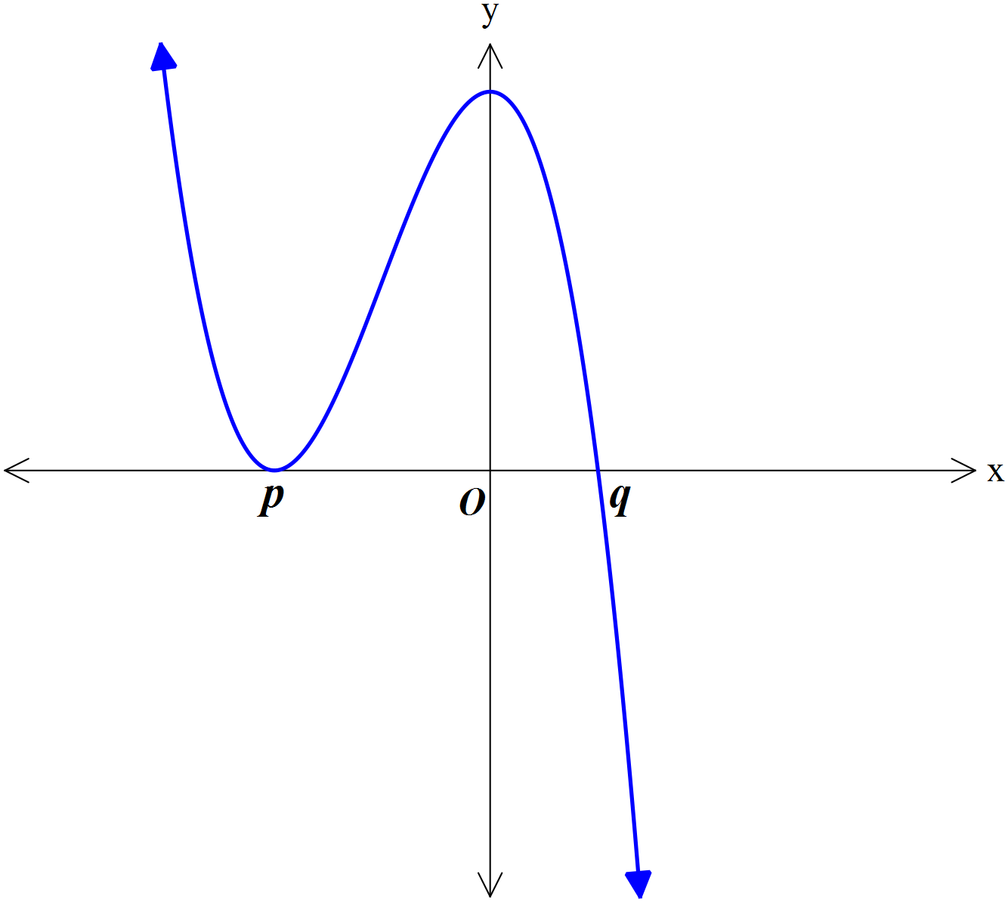

The graph above could be that of the function with rule

**Question 9**

The graph of takes the following transformations (1) to (3) in order:

1. Dilation by a factor of 2 from the axis
2. Reflection in the axis
3. Translation 3 units to the right.

If the transformed function is in the form , then the values of and respectively are:

**Question 10**

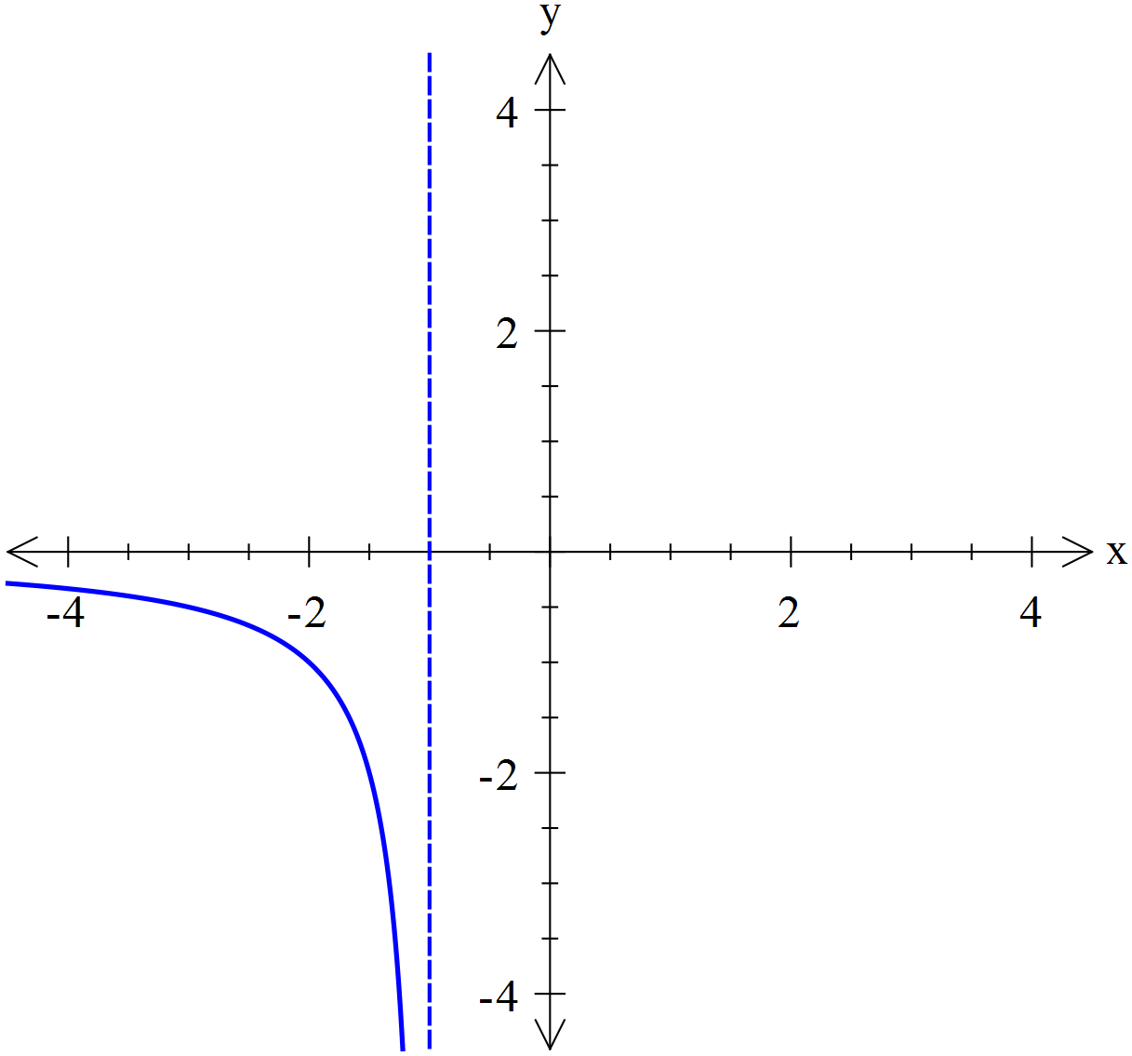

For the graph of shown above, which of the following is most likely to be the graph of ?

|  |  |  |
| --- | --- | --- |
|  |  |  |
|  |  |  |

**EXTENDED RESPONSE**

**Instructions:**

Answer **all** questions in the spaces provided.

In all questions where a numerical answer is required an exact value must be given unless otherwise specified.

In questions where more than one mark is available, appropriate working **must** be shown.

Unless otherwise indicated, the diagrams in this test are **not** drawn to scale.

**Question 1** (7 marks)

Gunamatta Beach lifeguard Dorothy Smart, situated at point P on the beach, spots a swimmer in difficulty in the water at point S, 75 metres along the beach and 40 metres to the north in the water. The line AB represents the shoreline; to the north is water.

Dorothy can travel at 5m/second along the beach and 3m/second in the water.

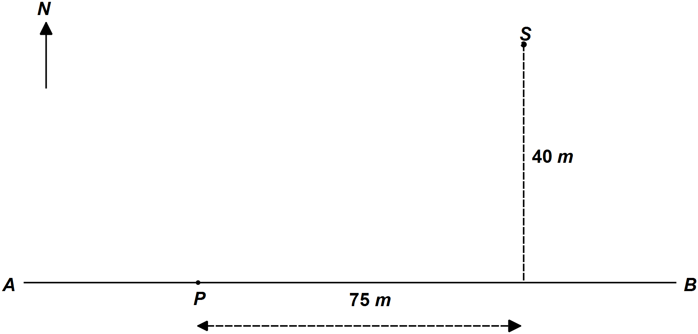

1. How long will it take Dorothy to reach the swimmer if she travels due east 75m along the beach and then straight to the swimmer 40m in the water? 1 mark
2. How long will it take Dorothy to reach the swimmer if she swims straight to the swimmer from point P to point S? 1 mark
3. Correct to 1 decimal place, how long will it take Dorothy to reach the swimmer if she travels due east 25m along the beach and then straight to the swimmer? 1 mark

Dorothy decides to run along the beach to a point X which is *x* metres from point P, then swim directly to the swimmer.

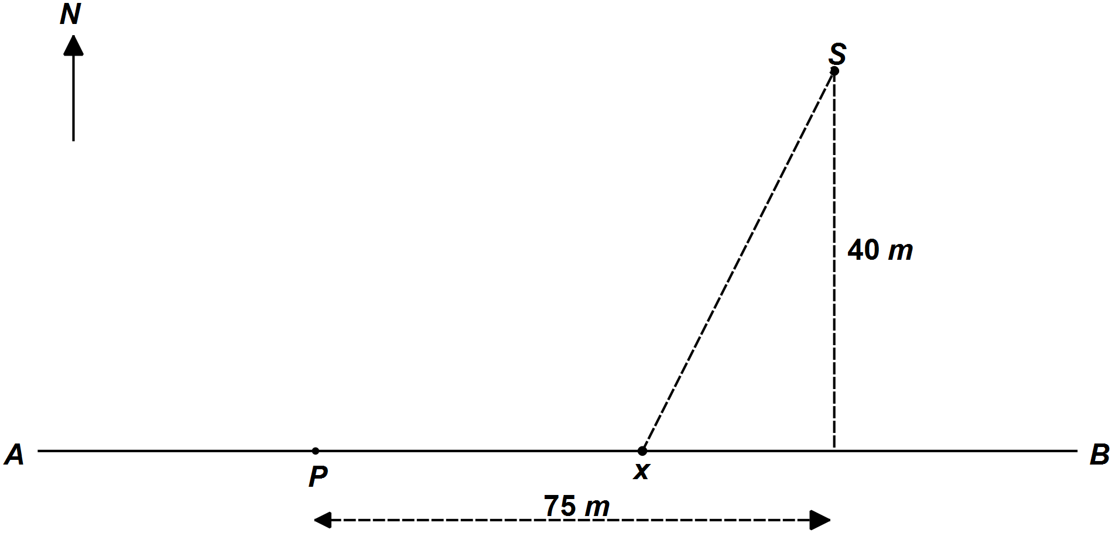

1. Show that the time taken for Dorothy to go from point P to point X and then to point S is given by the rule: 2 marks
2. Find the minimum time for Dorothy to reach the swimmer. 1 mark
3. How far should Dorothy run along the beach to ensure she reaches the swimmer in the shortest possible time? 1 mark

**Question 2** (8 marks)

Dorothy is treating a bottlenose dolphin injured on the rocky reef at the end of the beach. She administers a dose of an analgesic (pain reliever) at 12 pm. The concentration, units/cm3, of analgesic in the dolphin’s bloodstream hours after it is administered is modelled by the function

where is time in hours after 12 pm.

1. Sketch the graph of on the axes below. Label any stationary points and endpoints with coordinates.

2 marks

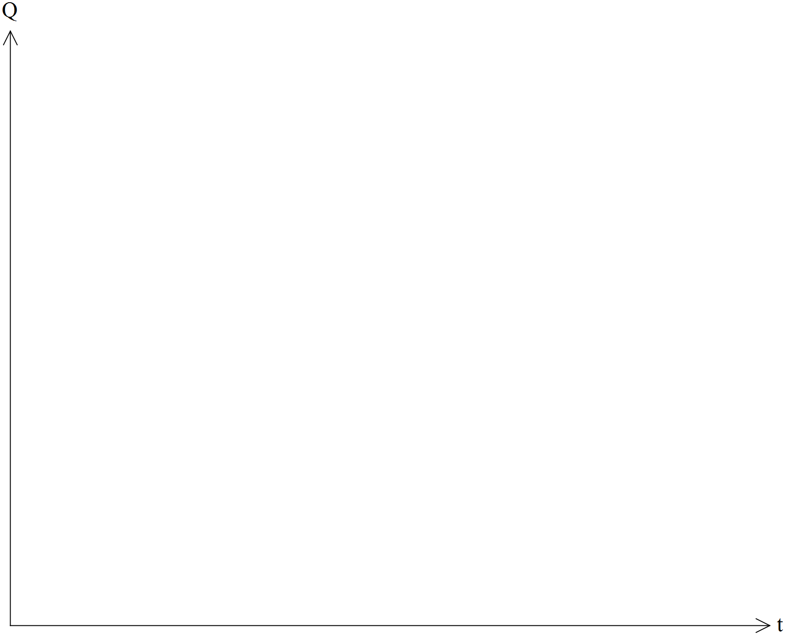

1. Find the maximum concentration of the analgesic. 1 mark
2. How long after the dose is administered does the maximum occur? 1 mark

The analgesic will provide pain relief when the concentration is above 1.25 units/cm3.

1. For what length of time, in hours correct to 2 decimal places, will the dolphin experience relief from the pain? 2 marks

Dorothy changes the dose to give the dolphin pain relief for twice as long.

1. Find the rule for such a function. Give your answer in the form . 2 marks

**END OF QUESTION AND ANSWER BOOKLET**